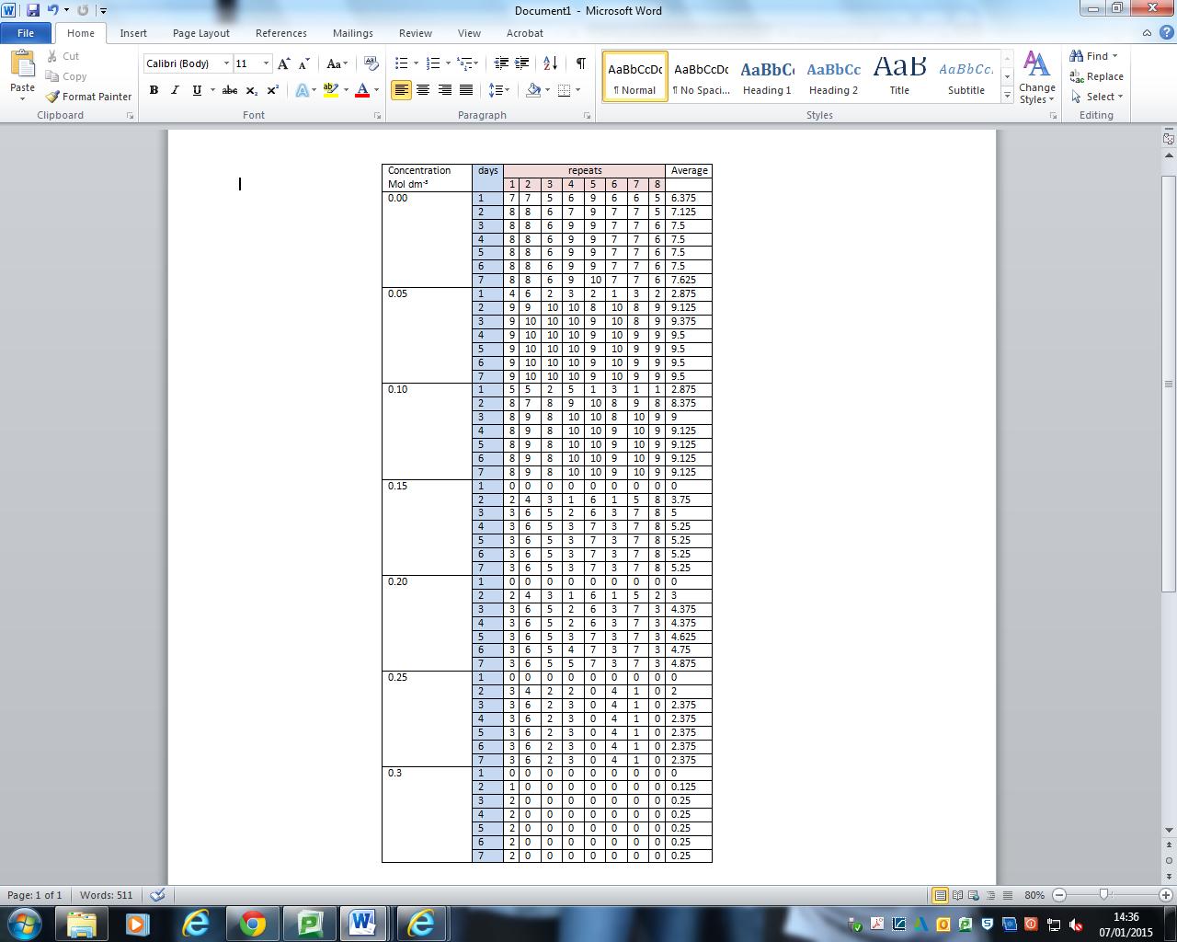

|  |  |  |  |  |  |  |  |  |  |  |
| --- | --- | --- | --- | --- | --- | --- | --- | --- | --- | --- |
| Salt Concentration (dm-3) | Day | Repeat | | | | | | | | Average |
| 1 | 2 | 3 | 4 | 5 | 6 | 7 | 8 |
| 0.00 | 1 | 7 | 9 | 6 | 10 | 8 | 8 | 7 | 8 | 7.875 |
| 2 | 10 | 10 | 9 | 10 | 10 | 9 | 10 | 10 | 9.75 |
| 3 | 10 | 10 | 10 | 10 | 10 | 10 | 10 | 10 | 10 |
| 4 | 10 | 10 | 10 | 10 | 10 | 10 | 10 | 10 | 10 |
| 5 | **10** | **10** | **10** | **10** | **10** | **10** | **10** | **10** | **10** |
| 0.05 | 1 | 6 | 9 | 6 | 5 | 5 | 6 | 4 | 8 | 6.125 |
| 2 | 7 | 9 | 7 | 8 | 5 | 7 | 5 | 8 | 7 |
| 3 | 8 | 10 | 9 | 9 | 5 | 8 | 6 | 8 | 7.875 |
| 4 | 8 | 10 | 10 | 9 | 9 | 8 | 7 | 8 | 8.625 |
| 5 | **8** | **10** | **10** | **9** | **9** | **9** | **10** | **10** | **9.375** |
| 0.10 | 1 | 5 | 2 | 6 | 6 | 3 | 1 | 3 | 4 | 3.75 |
| 2 | 7 | 3 | 6 | 6 | 4 | 4 | 4 | 4 | 4.75 |
| 3 | 9 | 3 | 6 | 8 | 6 | 8 | 5 | 5 | 6.25 |
| 4 | 9 | 5 | 6 | 8 | 6 | 9 | 6 | 6 | 6.875 |
| 5 | **10** | **6** | **6** | **10** | **7** | **9** | **8** | **7** | **7.875** |
| 0.15 | 1 | 3 | 2 | 4 | 3 | 3 | 1 | 1 | 0 | 2.125 |
| 2 | 4 | 3 | 6 | 3 | 3 | 1 | 2 | 0 | 2.75 |
| 3 | 5 | 6 | 9 | 3 | 4 | 1 | 2 | 3 | 4.125 |
| 4 | 7 | 7 | 9 | 4 | 5 | 1 | 3 | 4 | 5 |
| 5 | **8** | **8** | **9** | **5** | **6** | **2** | **5** | **5** | **6** |
| 0.20 | 1 | 2 | 1 | 1 | 3 | 0 | 3 | 0 | 0 | 1.25 |
| 2 | 2 | 3 | 2 | 3 | 1 | 3 | 1 | 1 | 2 |
| 3 | 4 | 4 | 3 | 3 | 1 | 4 | 2 | 2 | 2.875 |
| 4 | 4 | 5 | 4 | 3 | 2 | 4 | 2 | 3 | 3.375 |
| 5 | **6** | **5** | **6** | **3** | **3** | **4** | **2** | **4** | **4.125** |
| 0.25 | 1 | 2 | 1 | 0 | 0 | 1 | 0 | 0 | 1 | 0.625 |
| 2 | 2 | 2 | 0 | 0 | 1 | 0 | 0 | 1 | 0.75 |
| 3 | 2 | 2 | 1 | 0 | 1 | 0 | 1 | 1 | 1 |
| 4 | 2 | 3 | 1 | 0 | 2 | 0 | 1 | 1 | 1.25 |
| 5 | **4** | **3** | **1** | **0** | **2** | **1** | **2** | **2** | **1.875** |
| 0.30 | 1 | 0 | 0 | 1 | 0 | 0 | 0 | 0 | 0 | 0.125 |
| 2 | 0 | 0 | 1 | 0 | 0 | 0 | 0 | 0 | 0.125 |
| 3 | 1 | 0 | 2 | 0 | 1 | 0 | 0 | 0 | 0.5 |
| 4 | 1 | 0 | 2 | 0 | 1 | 0 | 0 | 0 | 0.5 |
| 5 | **2** | **0** | **2** | **0** | **1** | **0** | **0** | **0** | **0.625** |